Make a
Node.js
Package
Using
Class by
Reference
by
Christopher Andrew Topalian

All Rights Reserved
Copyright 2000-2024
Dedicated
to
God the Father

How to Make a Node.js Package

Let's make a package of functions for us to use in all of our projects, which we will install system wide on our computer. Later, we can even choose to upload our package to the internet and share it with the world.

By making a package of functions we can update our package anytime that we want and all of our projects will utilize the same updated package of functions!

This makes programming much easier, because we only have to make the package one time, instead of over and over again.

This allows us to be much more productive, because the package can easily be imported into any folder using npm link nameOfPackage

Let's make a package named cos

On the next pages we walk through creating the package that we name cos

cos stands for College of Scripting :-)

Class by Reference
Namespace
Class by Reference is a way to create a namespace for our functions to avoid name conflicts with other packages.

The static methods of our custom class named OurMath allow us to organize our functions in this single class without creating instances.
The static methods can be accessed directly on the class itself without needing to create an object instance.

No Instances and No State
By using static methods there's no need to create an object instance of OurMath. In this Class by Reference style of programming that we are using, the class doesn't maintain any state.

Using Static methods is a way to group related functions together in a way that's easy to access, but without needing to instantiate an object to use them. It creates a namespace that allows us to work with our package of functions without function name conflicts with other packages.

How to Create a Node.js Package

* We make a folder, named project1
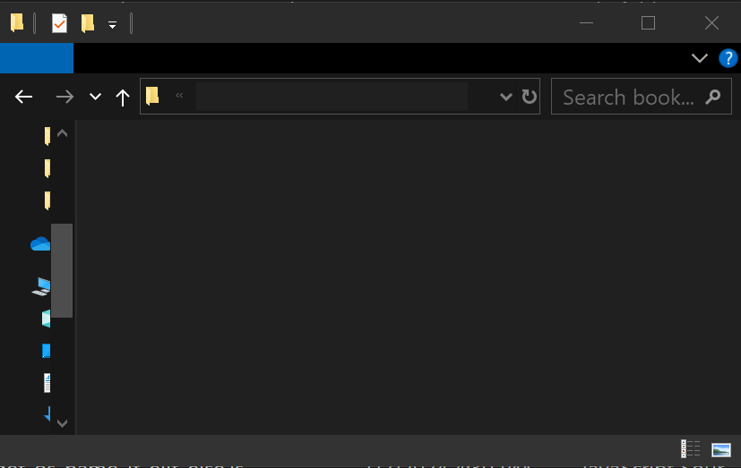

project1
Code
Code

* In project1 folder we make a folder named cos
cos
project1
project1

Naming Our Package

When naming packages, we never use:

* uppercase letters

* underscores

* commas

* special chars (!@#$%^&*())

Instead, we use

* lowercase only

* hyphens or dots

So, we can choose to name it,

our-package or ourpackage

but NOT ourPackage or our_package

We can choose to use dots, such as:

our.package or ourpackage.001
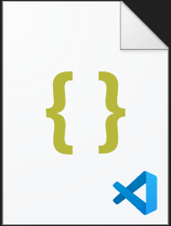
In the cos folder, we make a folder named src
src
cos
package.json
cos

In the cos folder, we also make a file named package.json
We have multiple ways to make the package.json file.
But, instead of using the npm method of making a package.json file using npm init let us create the file manually, without using the npm way, as shown on the next page.

package.json has meta data that is used to Install and Distribute Our Package

We create a package.json file, which defines our package and its metadata. This file is essential for distributing and installing our package across projects.

First, we make a new text file in VSCode Editor
and type the script that we see on the next page and save it as package.json

We make sure to save the package.json file inside of the cos folder.

NEXT PAGE SHOWS package.json

{
"name": "cos",
"version": "1.0.0",
"description": "Our Package",
"main": "src/index.js",
"scripts": {
"test": "echo \"Error: no test specified\" && exit 1"
},
"author": "Christopher Andrew Topalian",
"license": "",
"files": [
"src"
]
}

We have a src folder and a package.json file inside of our cos folder as shown here:
src
cos
package.json
cos

Inside of our src folder, we make a folder named math and we make an index.js file

math
src
index.js
src
On the next page, we show the index.js file code.

We Type the Code as we see it on the next page, and save it as index.js

We make sure that this index.js file is inside of the src folder.

This index.js file will reference the functions that we place in the math folder.

SEE NEXT PAGE for: index.js
// index.js

const OurMath = require('./math/OurMath');

module.exports = OurMath;

//----//

// Dedicated to God the Father
// All Rights Reserved Christopher Andrew Topalian Copyright 2000-2024
// https://github.com/ChristopherTopalian
// https://github.com/ChristopherAndrewTopalian
// https://sites.google.com/view/CollegeOfScripting
Inside of our math folder, we make three
.js files named divide.js, multiply.js and OurMath.js
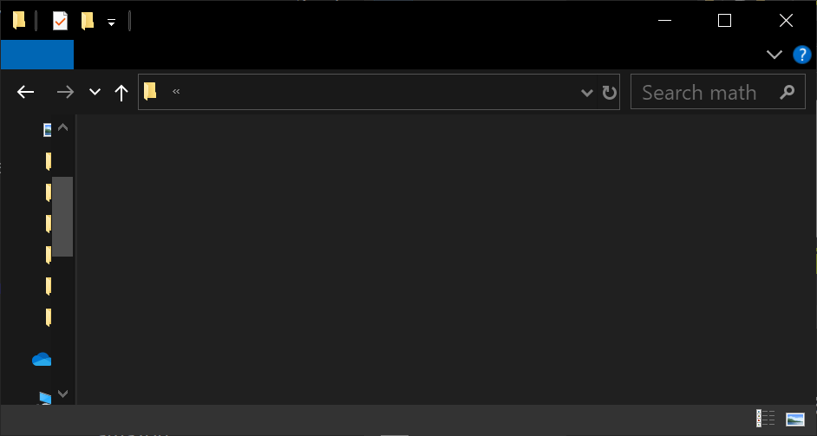
divide.js
math
multiply.js
math
OurMath.js

Thus, the two function files we are adding to our package are: divide.js and multiply.js

The class file we are adding references our divide and multiply functions.

On the next page, we see the function script that we save as multiply.js

NEXT PAGE SHOWS: multiply.js
// multiply.js

function multiply(a, b)
{
return a * b;
}

module.exports = multiply;

//----//

// Dedicated to God the Father
// All Rights Reserved Christopher Andrew Topalian Copyright 2000-2024
// https://github.com/ChristopherTopalian
// https://github.com/ChristopherAndrewTopalian
// https://sites.google.com/view/CollegeOfScripting

On the next page, we see the function script that we save as divide.js

NEXT PAGE SHOWS: divide.js
// divide.js

function divide(a, b)
{
return a / b;
}

module.exports = divide;

//----//

// Dedicated to God the Father
// All Rights Reserved Christopher Andrew Topalian Copyright 2000-2024
// https://github.com/ChristopherTopalian
// https://github.com/ChristopherAndrewTopalian
// https://sites.google.com/view/CollegeOfScripting

On the next page, we see the class script that we save as OurMath.js

NEXT PAGE SHOWS: OurMath.js
// OurMath.js

const divide = require('./divide');
const multiply = require('./multiply');

class OurMath
{
static divide(a, b)
{
return divide(a, b);
}

static multiply(a, b)
{
return multiply(a, b);
}
}

module.exports = OurMath;

//----//

// Dedicated to God the Father
// All Rights Reserved Christopher Andrew Topalian Copyright 2000-2024
// https://github.com/ChristopherTopalian
// https://github.com/ChristopherAndrewTopalian
// https://sites.google.com/view/CollegeOfScripting

How to Install Our Package Computer Wide

We Type cmd into the cos folder address bar and press Enter

src
cmd
package.json
cos

This opens our cos folder in the command prompt
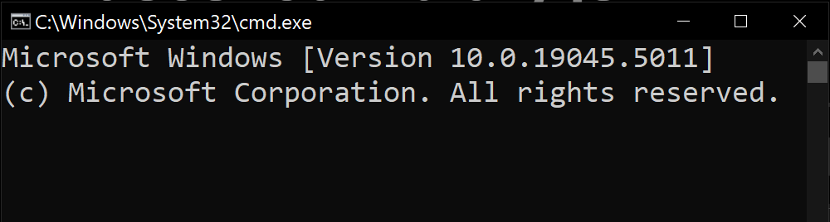
D:\Code\project1\cos> npm link

We type in the Command prompt:
npm link

press Enter
We have Installed Our Package System Wide!

Now, that we have used
npm link
which made our package available system wide, we can now easily link to our package from any of our Node.js project folders by using
npm link cos

This makes creating and updating our applications very easy :-)

The next page shows how to use our custom package.
To use our package in another folder, we first make a new folder anywhere else on our computer and name our folder project2

cmd
usesOurPackage.js
project2

In the address bar of project2 folder,
we type
cmd
press Enter

This opens the command prompt.

D:\Code\project2\cos> npm link cos

We type in the command prompt
npm link cos
press Enter

This will install the node_modules link folder of our package named cos into our project2 folder.

This way we can use the functions from our package in our project2 folder project.

Any time that we change a function in our cos package or add a function, those changes will now be useable in our project2 folder too.

This saves a lot of work, since now we only have to change the package of functions one time, but it allows us to use the package in as many projects as we want with the updated changes, just by typing in the address bar of any folder:
npm link cos
and pressing Enter

We make a new script in VSCode and save it as, usesOurPackage.js

We save usesOurPackage.js in a folder that we make any where on our computer. We named this new folder project2 to make things easy.

Thus, inside of project2 folder, we have the usesOurPackage.js file.

The code to the usesOurPackage.js file is on the next page.

We make sure to first link to our package by using npm link cos in project2 folder to be able to use the functions from our package named cos.

NEXT PAGE SHOWS usesOurPackage.js
// usesOurPackage.js

const OurMath = require('cos');

console.log(OurMath.divide(10, 5));
console.log(OurMath.multiply(4, 4));

//-//

process.stdin.resume();
process.stdin.once('data', function()
{
process.exit();
});

//----//

// Dedicated to God the Father
// All Rights Reserved Christopher Andrew Topalian Copyright 2000-2024
// https://github.com/ChristopherTopalian
// https://github.com/ChristopherAndrewTopalian
// https://sites.google.com/view/CollegeOfScripting

Updating Our Package is Easy

We type cmd into the cos folder address bar and press Enter

src
cmd
package.json
cos

This opens our cos folder in the command prompt
D:\Code\project001\cos> npm link

We type in the Command prompt:
npm link

press Enter
We can show what package links are present on our computer system using:
npm list -g --link

We can unlink a package system wide using:
npm unlink -g cos

To unlink the package locally from a project folder, we can use:
npm unlink cos

How to Paste Code from a PDF
that has Junk Characters.
How to Paste Code from a PDF
that has Junk Characters.
When we paste from a pdf into VSCode,
it might look like this:
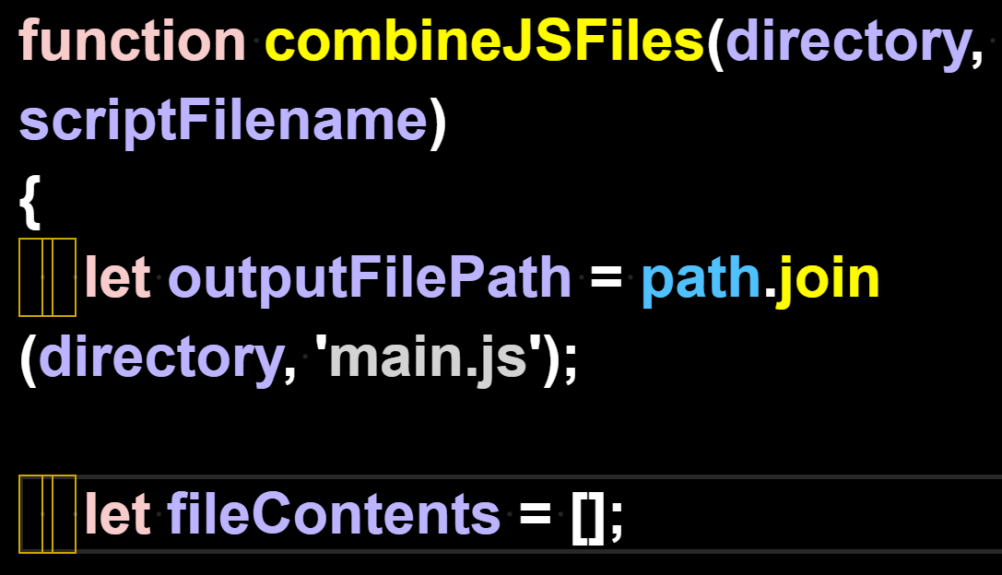

We can't leave those junk characters in the code, so we remove them with find/replace.

We Find 1 of the spaces.
We Replace All with the 1 space that we typed. This gets rid of the junk characters in the code.

We highlight 1 space with our mouse arrow:
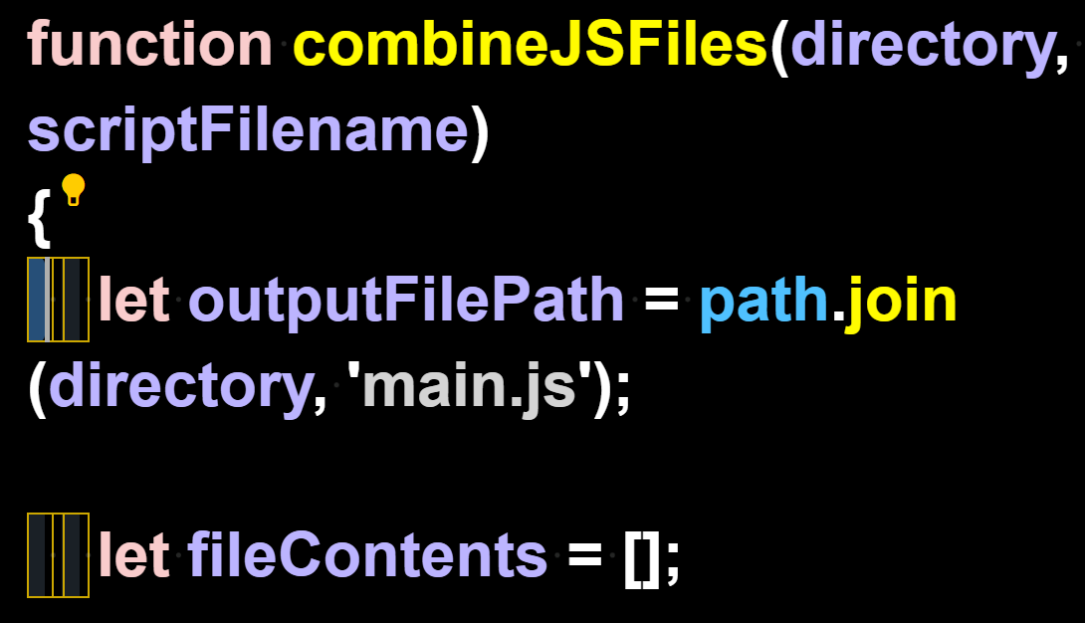
We press Control + H to open the Find/Replace feature and Replace All with our own Space
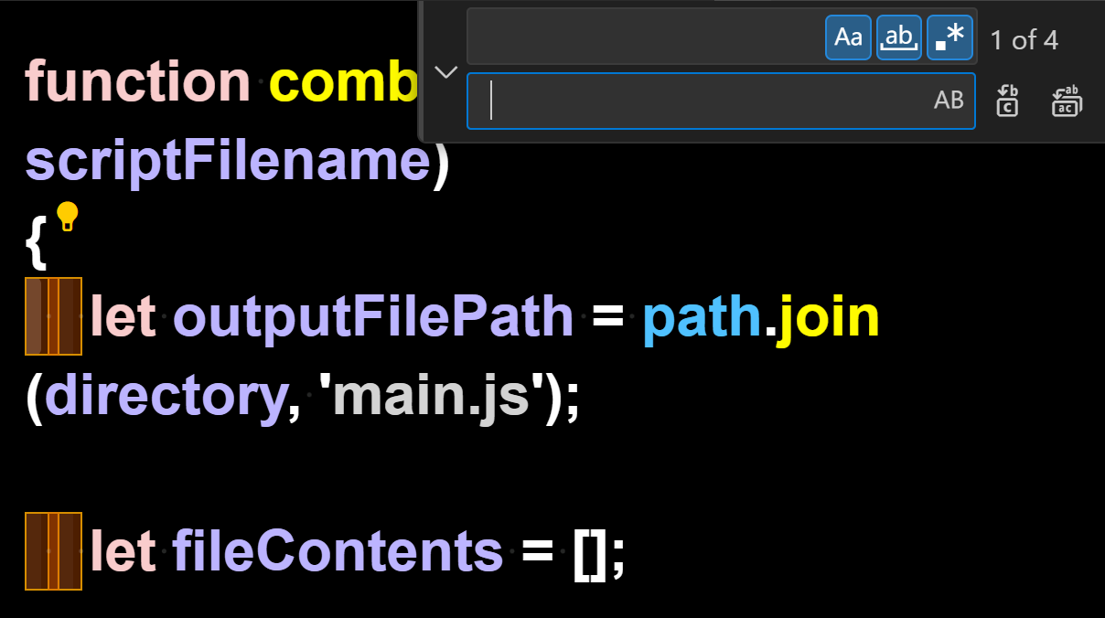

Here we see that the Find/Replace All has replaced the junk characters

with our working spaces instead:
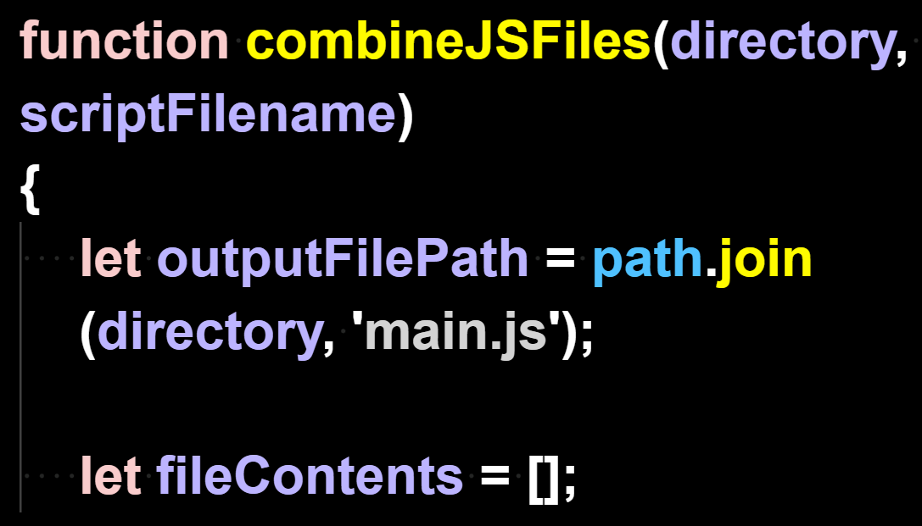

Now that the code
has no junk characters,
it can run.

True Artificial Intelligence System

Tautology
1111
Contra-
-diction
0000
XOR
0110
XNOR
1001
AND
0001
NAND
1110
OR
0111
NOR
1000
MI
1101
MNI
0010
LP
0011
LC
1100
RP
0101
RC
1010
CI
1011
CNI
0100
16-Gon
For More Tutorials:

CollegeOfScripting.weebly.com

CollegeOfScripting.wordpress.com

GitHub.com/ChristopherTopalian

GitHub.com/ChristopherAndrewTopalian

Youtube.com/ScriptingCollege

Twitter.com/CollegeOfScript

Rumble.com/user/CollegeOfScripting

Sites.google.com/view/CollegeOfScripting

Dedicated to God the Father

This book is created by the
College of Scripting Music & Science.

Always remember, that each time you write a script with a pencil and paper, it becomes imprinted so deeply in memory that the material and methods are learned extremely well. When you Type the scripts, the same is true.

The more you type and write out the scripts by keyboard or pencil and paper, the more you will learn programming!

Write & Type EVERY example that you find.
Keep all of your scripts organized.
Every script that you create increases your programming abilities.

SEEING CODE, is one thing,
but WRITING CODE is another.
Write it, Type it, Speak it, See it, Dream it.

www.CollegeOfScripting.weebly.com

